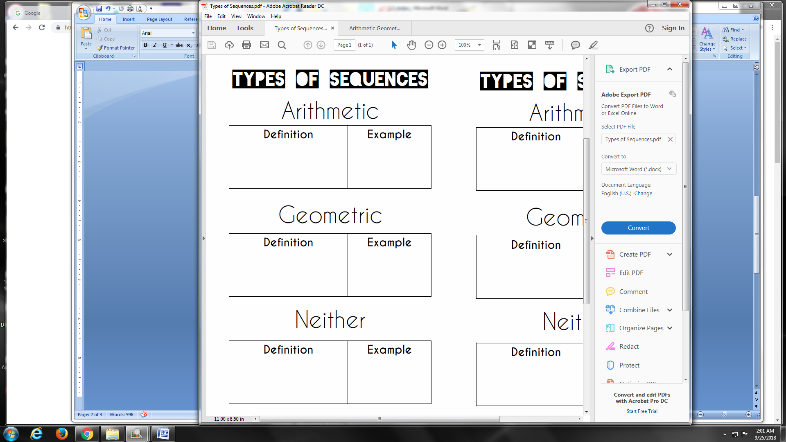

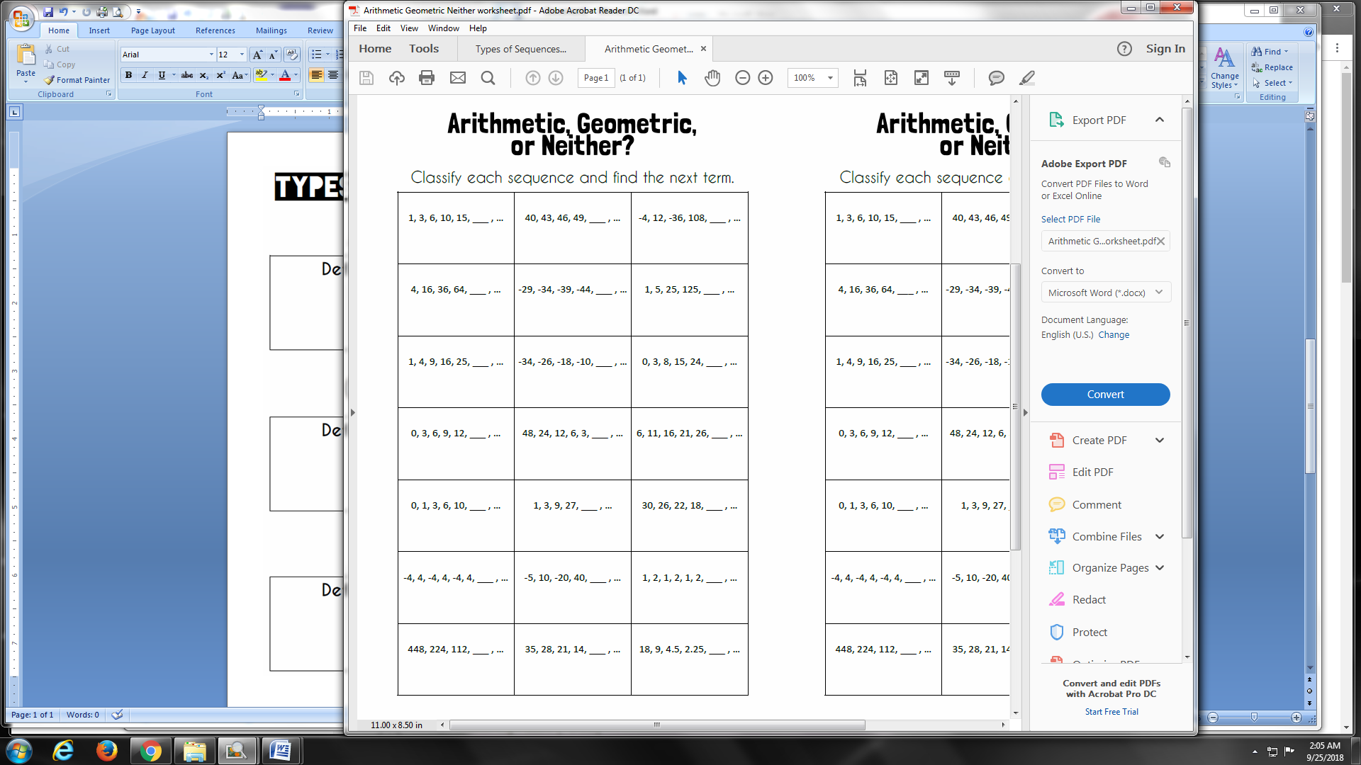

**III.** **Successive Differences:** some sequences are harder to find their pattern, so a method that can be used is called successive differences. Subtract each term to create a new number sequence and hopefully a pattern will emerge. If not, then subtract again, and again, until the pattern is obvious. Then add to get the last term in each sequence until you are back up to the original sequence.

**EXAMPLES:** use successive differences to find the next term in the sequence

1. 2, 6, 22, 56, 114, _____ 2 6 22 56 114
2. 1, 4, 11, 22, 37, 56, _____ 1 4 11 22 37 56